Module 6 Portfolio Milestone

Nathan Rogers
Colorado State University Global
Course Code: CSC506
Professor Farr
05/25/2025

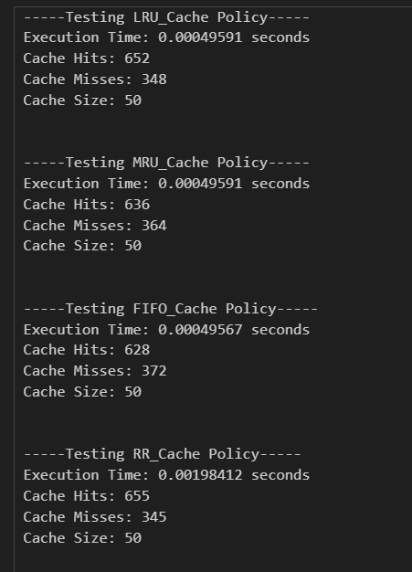

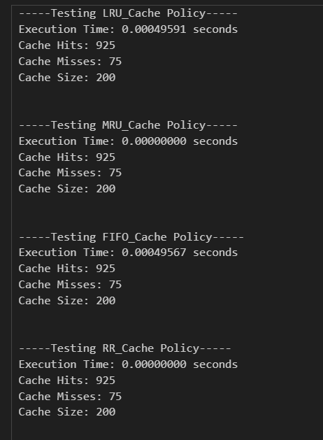

Introduction
“Caching is a system design concept that involves storing frequently accessed data in a location that is easily and quickly accessible.” (Caching - system design concept 2024). The purpose of this project is to become more familiar with implementing and understanding different cache replacement policies within a Cache Simulator. There are four replacement policies included in this simulator: LRU (Least Recently Used), MRU (Most Recently Used), FIFO (First In First Out), and RR (Random Replacement). “Caches have a limited capacity, though, and the system must choose which data to delete when the cache is full. The cache eviction policies provide the criteria for choosing which data to replace.” (Cache eviction policies: System design 2024). Within this simulator, the hit and miss rate will be evaluated and compared across each replacement policy.
Optimization and Refinement Process
From the first iteration, we were able to make several improvements to our code and test cases. The first optimization made was improving Random Replacement. This was the only eviction policy to not utilize a dictionary and thus made the lookup time O(n) since we were linearly searching through a list until we found the element to remove. By storing the keys in a separate list and the data in a dictionary we were able to improve the lookup time to O(1) which is similar to the other eviction policies.
The other improvement we made was to the test data. In the previous iteration I was generating a test list by linearly inserting data from the global data set and restarting to the beginning at a random point. While in theory this worked to get repeated data, in practice we weren’t using a good portion of the data at the end of the global data set. The selection process was improved by utilizing random.choice(key) selections in which case we used the whole dataset and ended up with repeat data to use during our cache testing. While this improvement didn’t improve hit rates within testing it did improve selection to a more well-rounded selection process. The added random selection represents a more realistic representation of workloads.
The final improvement was to the data test section. A loop was added so that multiple workloads could be tested in one go as opposed to running the same section of code n times. I had issues at first with this loop as all my data was yielding the same hit values. I noticed after some time, by testing each eviction policy separately, I wasn’t generating new data between iterations, so each run was just the same. After I started generating new data, I got new results which proved to me that everything was working normally.
Data Analysis
I posed an idea in my last essay after analyzing the initial data that I want to address, “Perhaps cache size influences hit and miss rate with a small cache size having a negative effect over a larger cache size.”. Not only did I test larger cache sizes, but I also increased the amount of data to be tested. It looks like the cache size does indeed influence the average hit within the cache. As I increased the size of the cache the average hit increased for all caches regardless of the eviction policy. The average hit also seemed to level out with all eviction policies yielding similar average hit values.
There was also a point at which all hit rates were the same. For example, in the first chart, cache sizes of 50 and 100 yielded similar results and each cache eviction policy yielding exactly the same average hit values. This also occurred in the second chart for cache sizes above 100. This makes me wonder, is there a hidden bug somewhere? Or is this a limitation of using random data to simulate cache hits and misses? Perhaps in the final iteration I can dig into this to gather an answer to these questions.

References
CSC506: Design and Analysis of Algorithms home | zyBooks. Zybooks. (n.d.). https://learn.zybooks.com/zybook/CSC506-1_10
Cache eviction policies: System design. GeeksforGeeks. (2024, October 29). https://www.geeksforgeeks.org/cache-eviction-policies-system-design/
Caching - system design concept. GeeksforGeeks. (2024b, December 20). https://request.geeksforgeeks.org/?p=468000

